Small Business - Team 3

Galo Guerra, Jiahua Zhang, Xingru Chen, Andrew Wang

Final Report

**Analysis and Key Questions:**

Our group was tasked with finding answers to the key questions of what businesses exist in District 4, and what businesses are overrepresented. In our research, we determined that we could categorize businesses in two ways. For most businesses, this meant using their NAICS 2-digit identifier, such as Healthcare and Social Assistance businesses. However, two specific 2-digit categories, Retail Trade and Other Services, we felt were too broad and thus split these into their NAICS 6-digit identifiers. This ended up giving us 58 different business types to analyze that were present in Boston’s District 4:

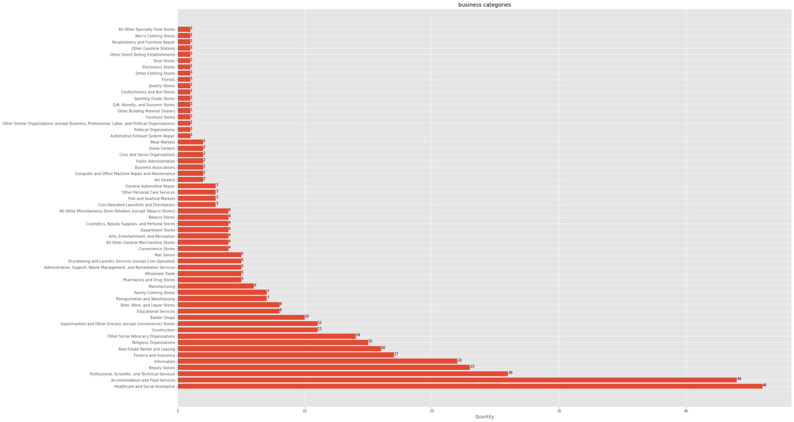

Notable amongst these businesses were the following categories: Healthcare and Social Assistance with 46 businesses, Accommodation and Food Services with 44 businesses, Professional, Scientific, and Technical Services with 26 businesses, Beauty Salons with 23 businesses, and Information with 22 businesses. These businesses are the most represented within District 4, and are all contenders for being overrepresented in District 4. However, most notable is Beauty Salons, as this is the only 6-digit identifier that is in the top 5. This is probably the most clear answer for what business is overrepresented, as it is the only very specific identifier that contends with the less specific identifiers numerically.

From there we mapped the most common businesses within district 4, assigning each to a color to provide a clear view of how these businesses are laid out. As well, we created two centroids in order to provide a clearer picture of how close the business types are to one another:

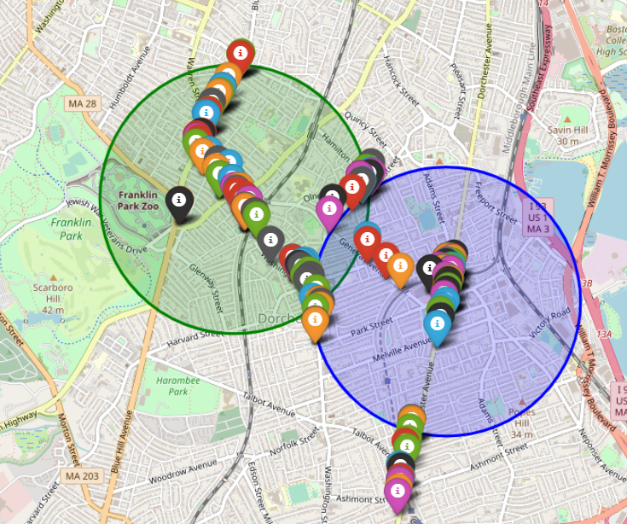

From there, we were able to compare the results in district 4 to those in other districts. In comparison to the other 8 districts, we see a lot of similarities in the most frequently seen businesses. We created a graph to see the number of businesses in all other districts first:

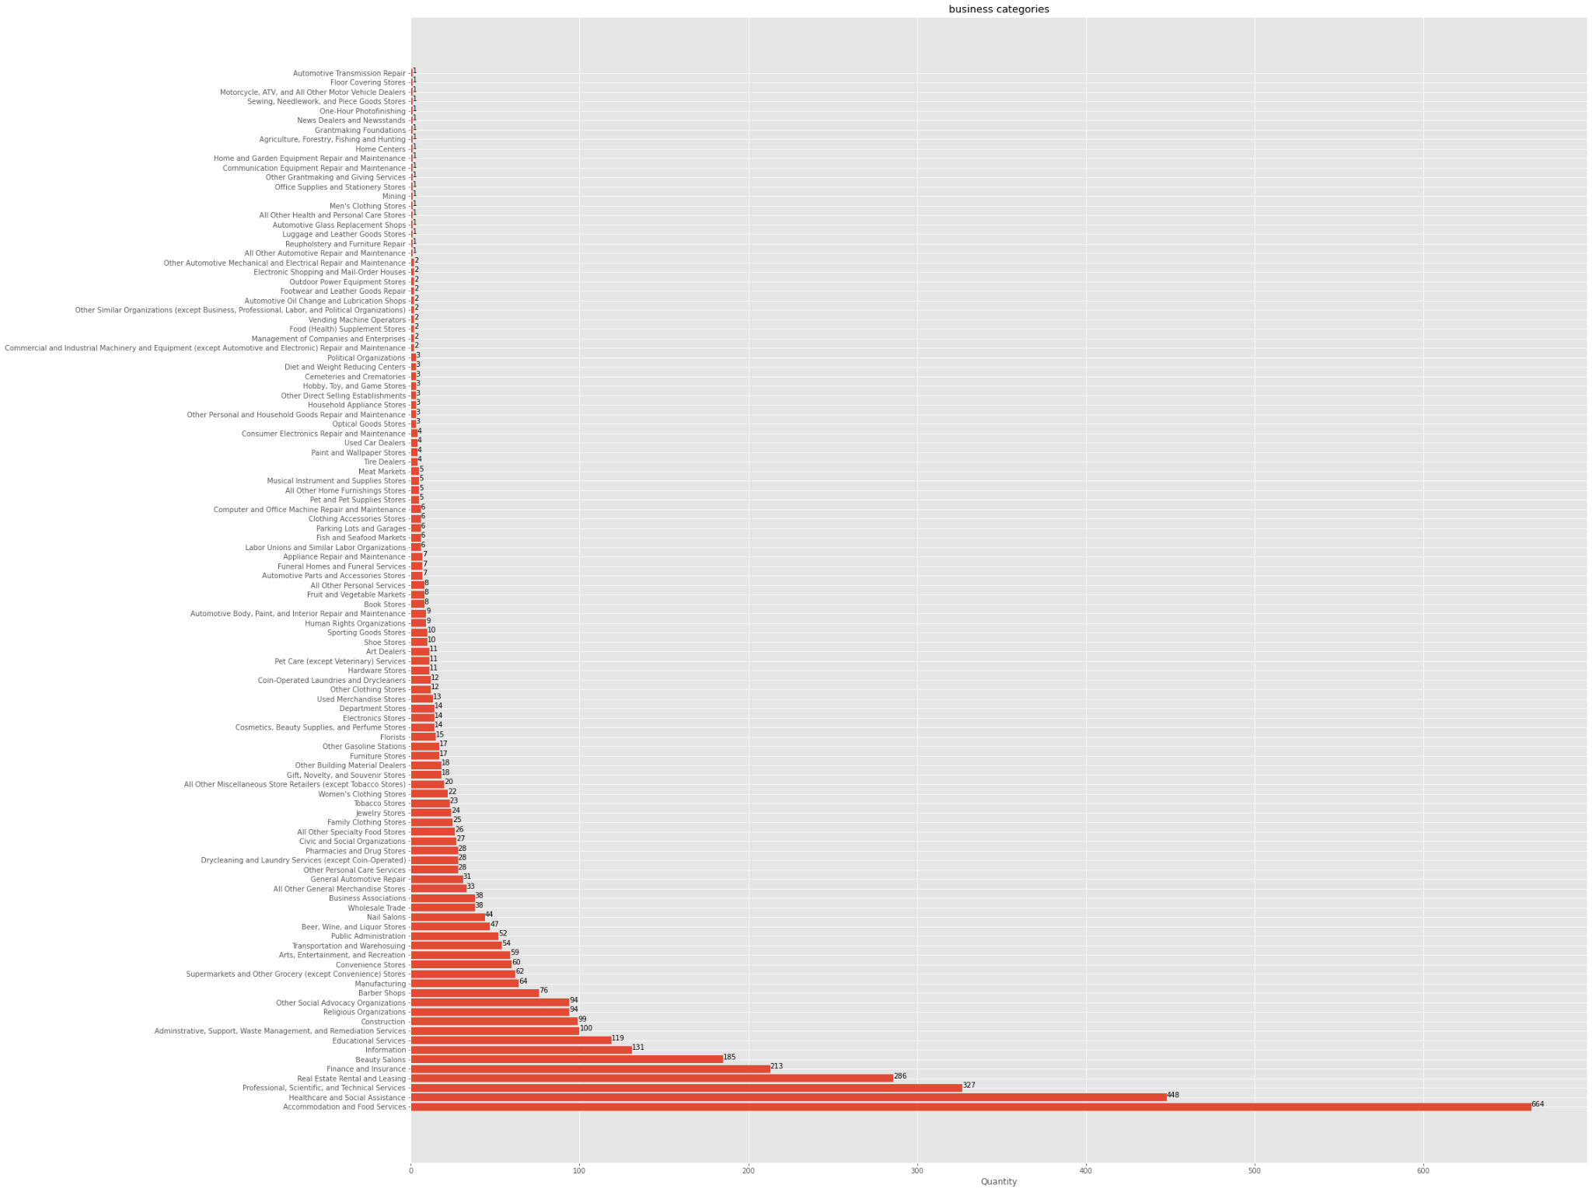

Fram there, we separated the largest categories and created a multiple bar graph that shows every district, and the five most represented business types in every district:

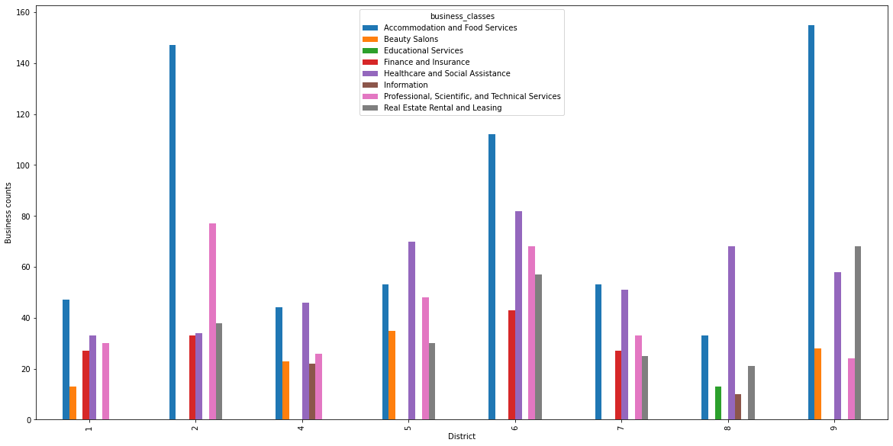

Notably, all districts share: Accomodation and Food Services, Healthcare and Social Assistance, and Professional, Scientific, and Technical Services. As well, districts 1, 5, and 9 interestingly share the category of Beauty Salons. This was surprising as it appears that maybe Beauty Salons could be viewed as overrepresented over multiple districts. Interesting to note is that only District 8 has educational services in its top 5 categories.

As per the client’s request, we took a deeper look at two large 2-digit categories. Those being Educational Services and Professional, Scientific, and Technical Services. We created new graphs to display the breakdown of these two categories. First is the Educational Services:

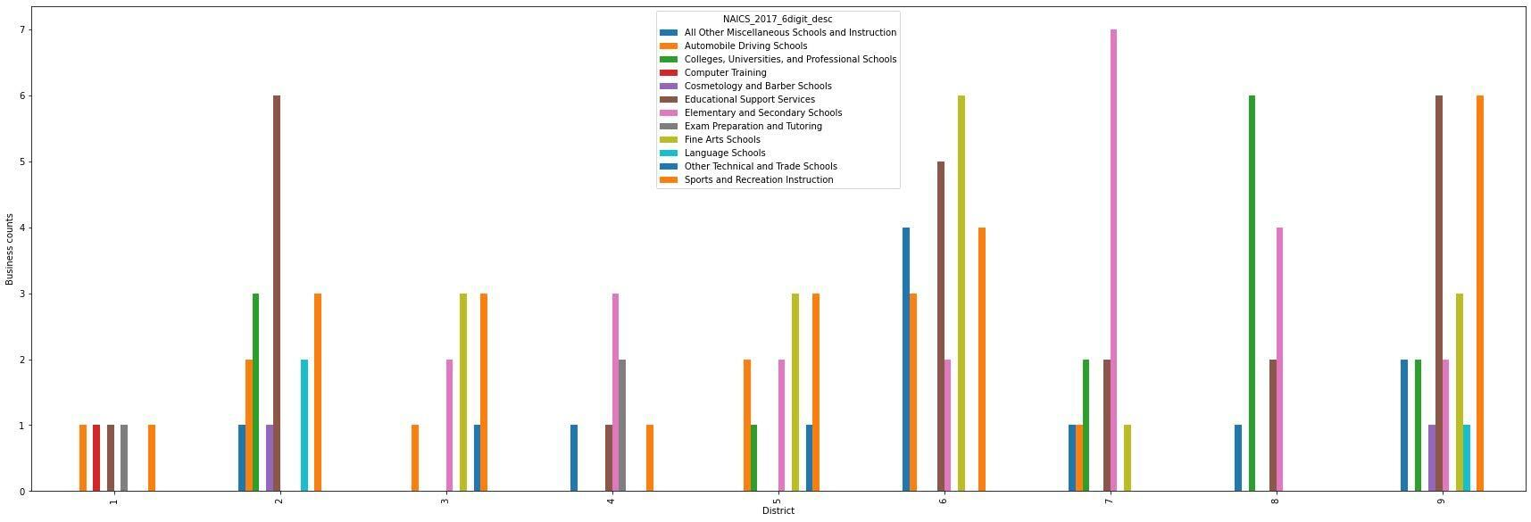

One thing to note is that no district has more than 7 of any 6-digit type of Educational Services. As well, we see that the majority of the educational services in district 8 are Universities, and this tracks as district 8 contains Back Bay and the surrounding universities. For district 4, its two largest forms of education are Elementary and Secondary Schools, and Exam Prep and Tutoring. Overall though, district 4 trends toward the bottom of the list in terms of number of businesses of this type.

The other category we were asked to look further into was Professional, Scientific, and Technical Services. Originally, our group created a graph of every single 6-digit business of this category. Of note from that graph. is that district 6 has over 30 Public Relations Agencies, while the next closest to that number is district 5 with less than 20 Public Relations Agencies. The full breakdown of every single type of Professional, Scientific, and Technical Services business was too hard to read, so we then created a chart that displayed only the most prominent ones:

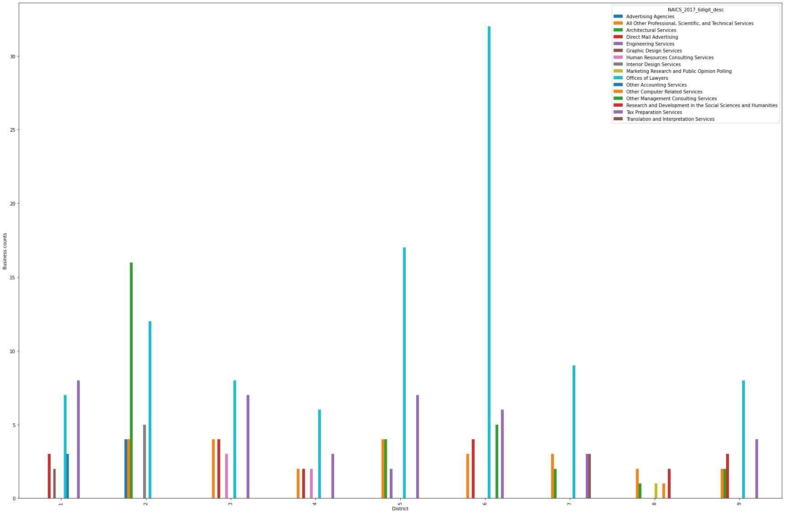

Of note is that district 4 still stands far and away noticeable with over 30 Offices of Lawyers. For district 4, it's interesting to note that no single type of Professional, Scientific, and Technical Services business was overtly prominent. Despite being one of the most prevalent business types from our original findings, it appears that this is not due to any specific type of business, and is more widespread over a multitude of these 6-digit descriptions.

As well, it was tasked to us to create measures for the number of businesses per capita in every district and all of Boston. We found that the number of small businesses per person is very small, indicating that in District 4 alone, there are 187 people to every business, which is the third highest of the 9 districts. Perhaps worrying, if the majority of that number are devoted to businesses in Healthcare and Social Assistance. However, the large number of people to business may be a reason for food services being a large proportion of the businesses in District 4, and may even indicate that there is room for the number to grow in the future without becoming overcrowded within the district. Here is the results we gathered:

|  | Population | Number of Businesses | Businesses per Capita | People per business |
| --- | --- | --- | --- | --- |
| District 1 | 76,830 | 292 | 0.0038005987244565925 | 263.1164383561644 |
| District 2 | 77,466 | 652 | 0.008416595667776831 | 118.81288343558282 |
| District 3 | 73,285 | 505 | 0.006890905369448045 | 145.11881188118812 |
| District 4 | 72,917 | 388 | 0.005321118532029568 | 187.93041237113403 |
| District 5 | 75,436 | 538 | 0.007131873376106899 | 140.21561338289962 |
| District 6 | 76,523 | 814 | 0.010637324725899403 | 94.0085995085995 |
| District 7 | 72,147 | 418 | 0.005793726696882754 | 172.60047846889952 |
| District 8 | 76,370 | 229 | 0.0029985596438392038 | 333.49344978165936 |
| District 9 | 74,673 | 631 | 0.008450176101134278 | 118.34072900158479 |
| Total | 675647 | 4467 | 0.00661144058953862 | 151.2529661965525 |

**Extension Project:**

For our extension project, our group chose to look at Boston’s 2010 Climate Social Vulnerability Data. This dataset provides information on different types of vulnerable populations in Boston (such as the elderly, children, minorities, low income households, etc.), and provides their locations based on the 2010 census tracts. We were able to use this data to map out the census tracts located in Dorchester and Mattapan, the two largest parts of District 4:

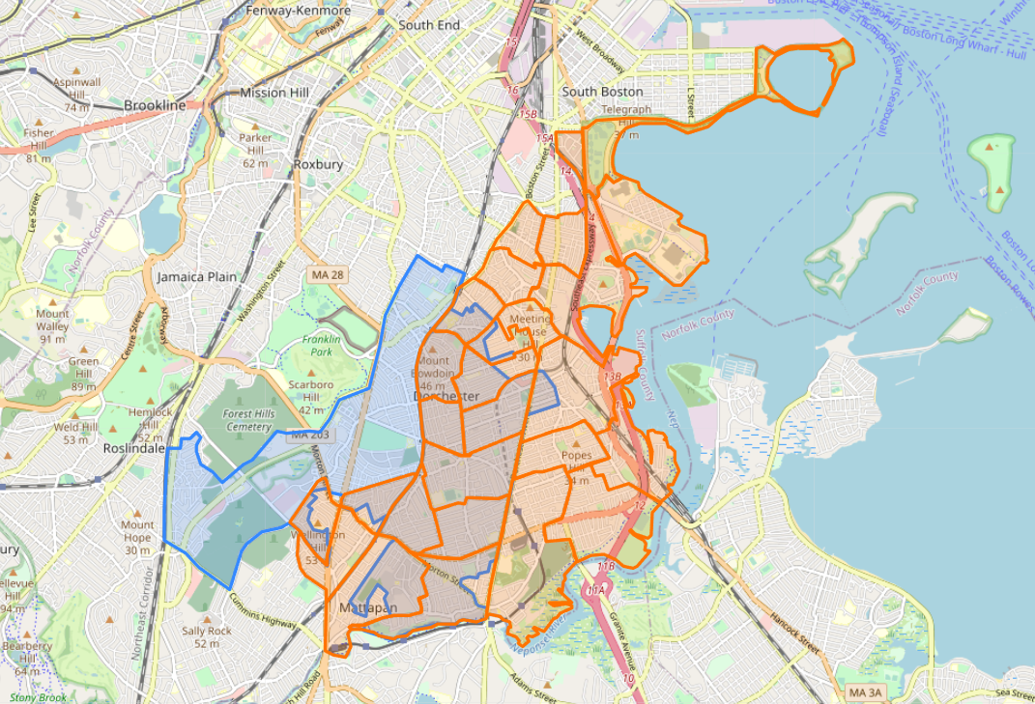

From there, we were able to find the overlap of the vulnerable populations and District 4:

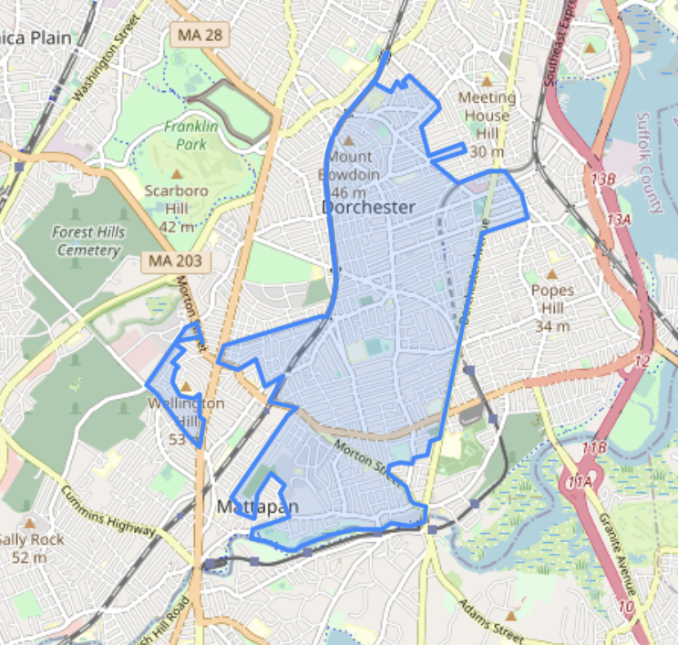

After getting access to the shapefiles for all districts, we were then able to map out the numbers of vulnerable populations for every district:

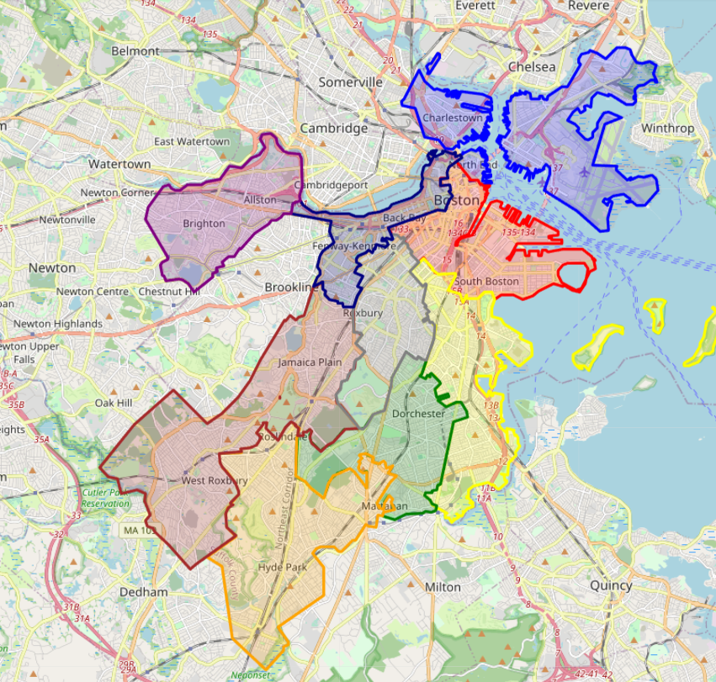

The way we broke down the numbers for every district was to divide the neighborhoods into the neighborhoods which make up the largest part of every district. Unfortunately, likely due to privacy concerns, the vulnerable populations data does not provide specific information about where these populations are located. Rather, it provides more general information like neighborhood, but with little focus or specialization that would allow us to be able to cut up the neighborhoods for our intended use. These were the numbers we were able to gather:

District 1:

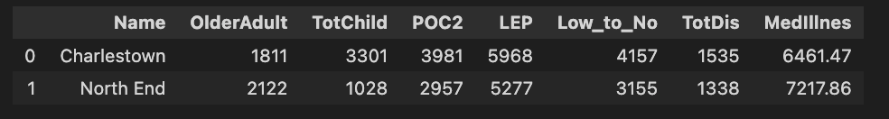

District 2:

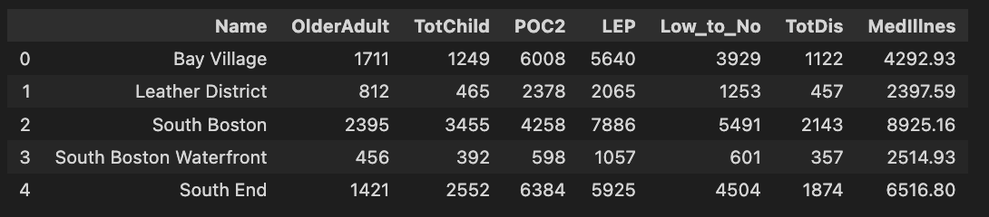

District 3:



District 4:



District 5:

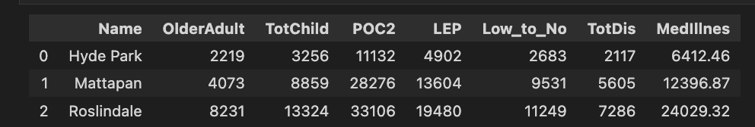

District 6:

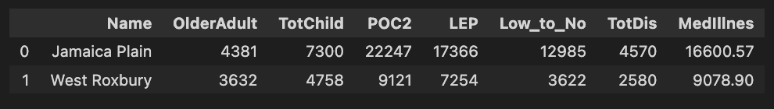

District 7:



District 8:

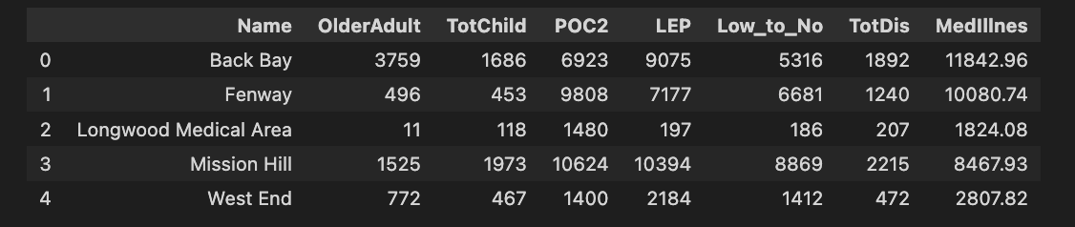

District 9:

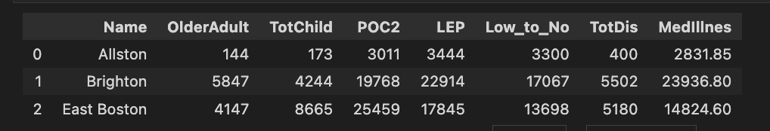

One thing to note from that data above, is that the population data does not provide information for people that satisfy multiple vulnerabilities. If you add the individual numbers, some of the above will be larger than the provided district populations on pages 4 and 5. This prevented us from getting clear ideas like what percentage of a district's population is vulnerable, and how many people satisfy multiple categories.

In order to more easily visualize the data, we create pie charts for every type of vulnerable population. This allows us to see the breakdowns of the different types of vulnerable populations across all 9 districts.

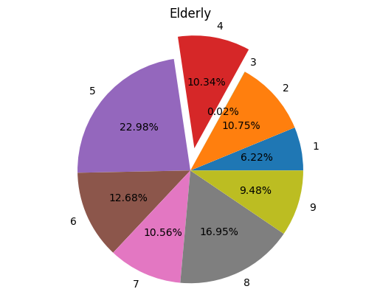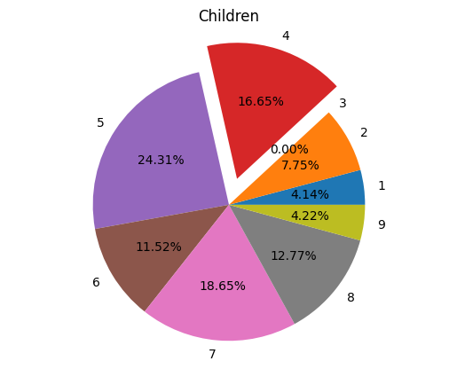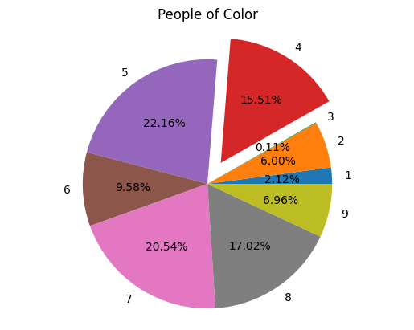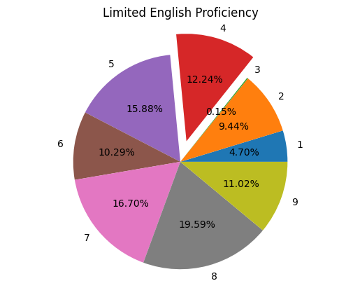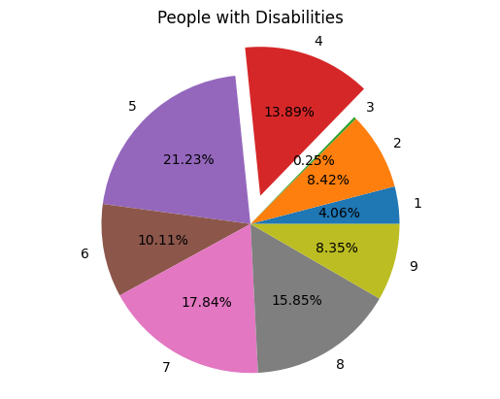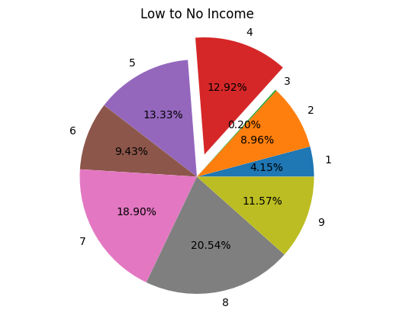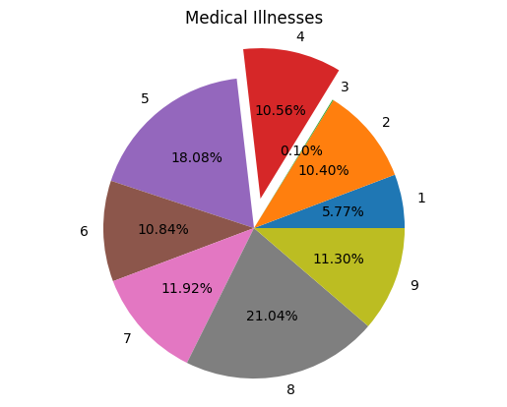

Interesting to note from these graphs, none of the vulnerable populations are most represented in District 4. District 4 portions are largest for the populations of Children, People of Color, and People with Disabilities in that order. This is despite District 4 having a much larger number of people with Limited English proficiency than those with disabilities, showing the disparity in numbers across all districts in the number of people with disabilities compared to the other types of vulnerable populations. District 4 has a total population of 72,917, and contains 17,424 children, 50,778 POC, and 9,819 people with disabilities. This was important for people with disabilities, as we found that people with disabilities make up 13.47% of district 4’s population, but district 4’s population of people with disabilities makes up 13.89% of people with disabilities in all of Boston. In contrast, POC make up 69.64% of district 4’s population, but District 4 makes up only 15.51% of the population of POC in Boston.